**Date: 18/04/2024**

**Task:**

1. Write an HTML code to display images as in the following given output by using table and image tags. 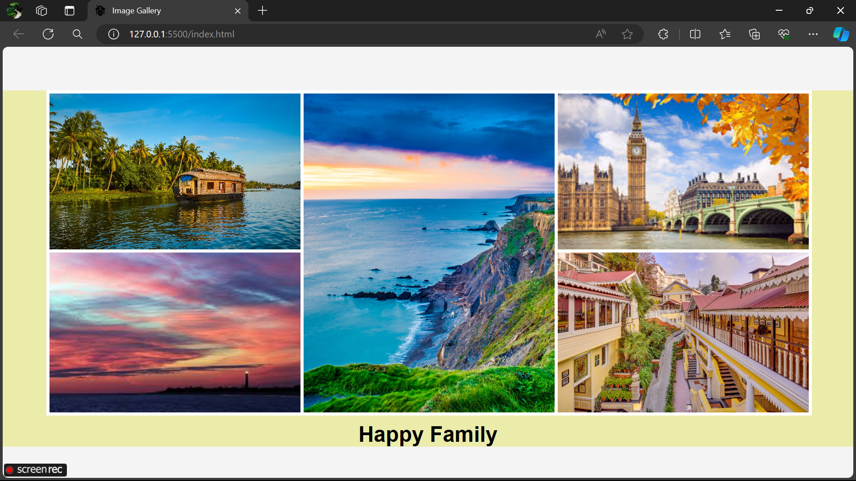
2. Write an HTML document table with lists of veg food and Non-veg with unordered lists.

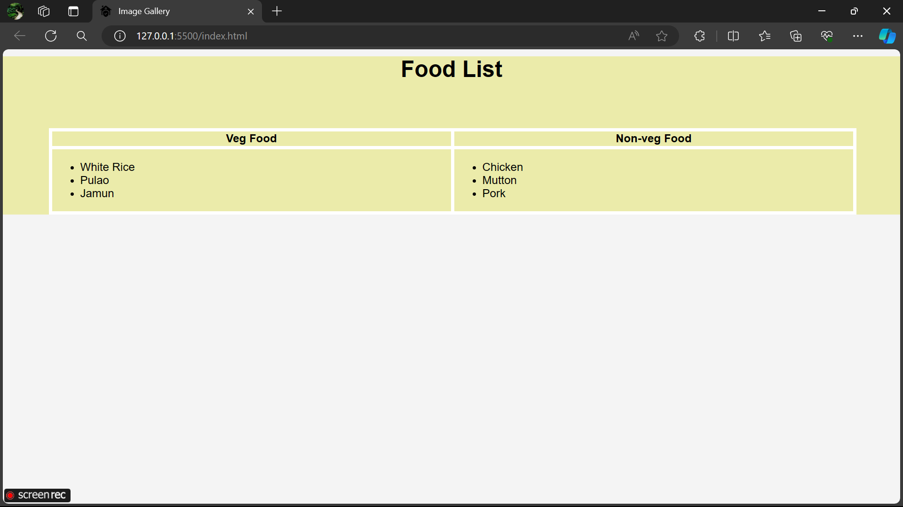

1. Write an HTML document to play audio and video files.

